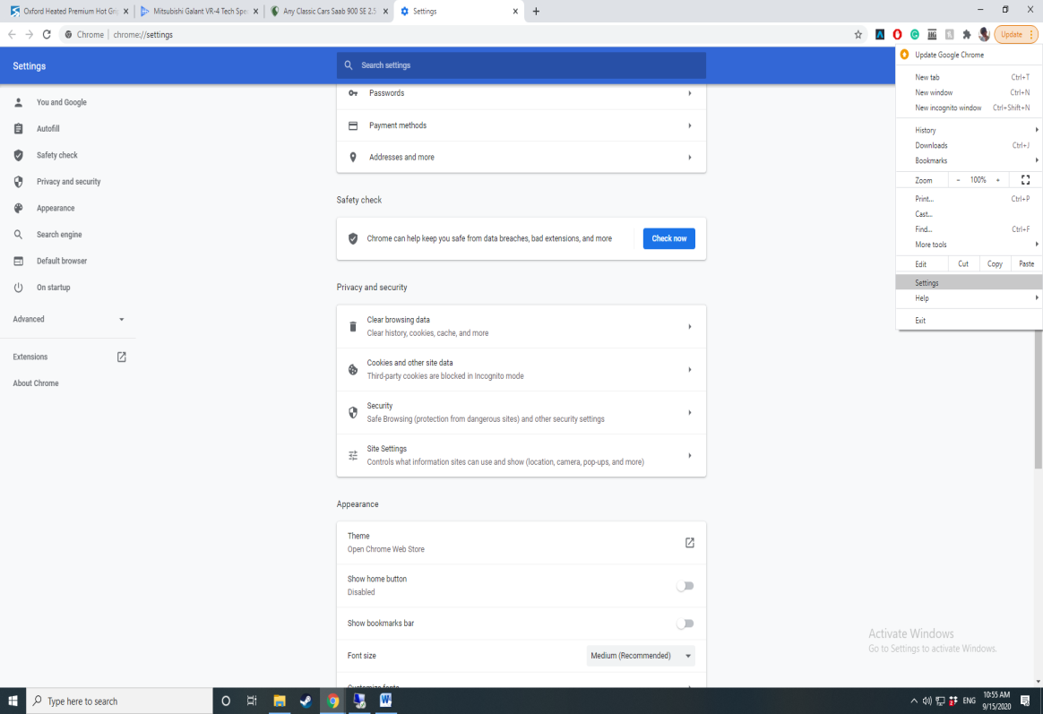If you are getting a message that your account has been locked please follow the instructions below

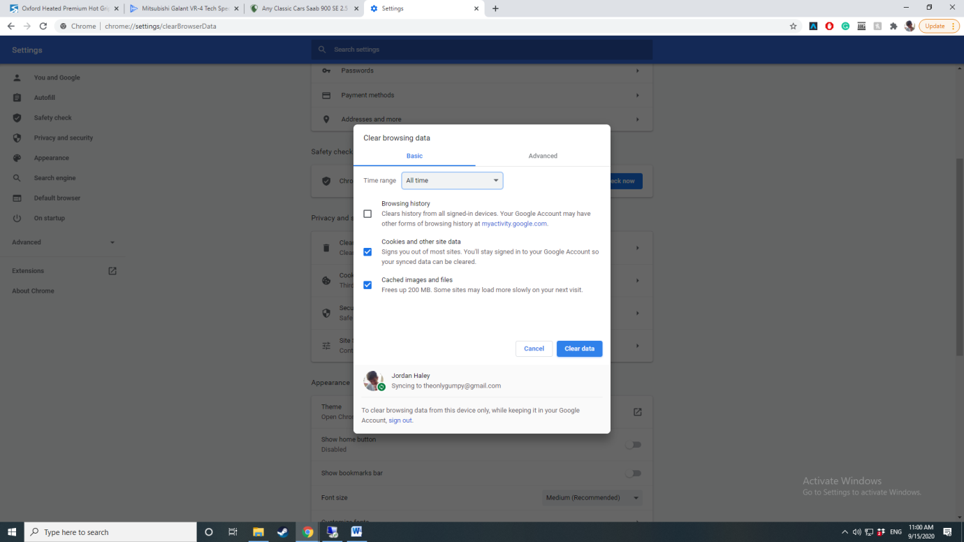

You then need to only select cookies and cached imagines and files and a suitable time range (All time). Once you clear this data it will lose any memory of the old style GWA accounts and they should be able to login into their new account without an issue.

On Chrome you will need to open settings which you can find by clicking the three dots in the top right and selecting settings from the list.

When on the settings page you will need to scroll down until you find Privacy and security and the clear browsing data.